**Slide 1: Title Slide**

* Title: COVID-19 Twitter Sentiment and Topic Analysis
* Subtitle: Unveiling Public Sentiment and Discussion Themes Using Data Science
* Your Name
* Date

**Slide 2: Project Objective**

* Title: Analyzing COVID-19 Discussions on Twitter
* Content:
  + Goal: To uncover what people are feeling and talking about concerning COVID-19 on Twitter.
  + Why It Matters:
    - Understand public reaction during a major global event.
    - Help health officials and policymakers respond effectively.
  + How We Do It:
    - Use special tools (NLP techniques) to read and make sense of thousands of tweets.
    - Analyze sentiments (positive or negative feelings) in the tweets.
    - Identify key topics being discussed.
  + What We'll Find Out:
    - Discover how public opinion changed over time during the pandemic.
    - Learn what topics caught most people's attention.
    - Offer insights to those who make decisions about public health and safety.

**Slide 3: Data Preparation**

* **Tools/Libraries:** pandas, numpy
* **Functions:** .read_csv(), .concat(), .dropna(), .unique()
* **Why and How:** Used for loading, merging, and cleaning datasets to create a cohesive data source for analysis.

**Slide 4: Natural Language Processing (NLP)**

* **Tools/Libraries**: **nltk**, **gensim**, **TextBlob**
* **Functions**: **TextBlob()**, **nltk.download()**, **gensim.models.LdaMulticore()**
* **Why and How**: Applied tokenization, lemmatization, and stopword removal for text normalization, and TextBlob for sentiment analysis to quantify tweet sentiments.

**Slide 5: Sentiment Analysis**

* **Tools/Libraries**: **TextBlob**
* **Functions**: **TextBlob().sentiment**
* **Why and How**: To calculate polarity and subjectivity scores for each tweet, giving a measure of sentiment and objectivity/subjectivity.

**Slide 6: Topic Modeling**

* **Tools/Libraries**: **gensim**
* **Functions**: **corpora.Dictionary()**, **LdaMulticore()**
* **Why and How**: Used LDA to identify dominant topics within the tweets and characterize the discussion themes.

**Slide 7: Data Visualization**

* **Tools/Libraries**: **matplotlib.pyplot**, **seaborn**
* **Functions**: **.lineplot()**, **.barplot()**, **.heatmap()**
* **Why and How**: To represent sentiment trends and topic distributions over time, and to show correlation between different variables.

**Slide 9: Insight 1 - Sentiment Polarity Over Time**

* **Visualization**: Line Graph of Sentiment Polarity vs. Time.

* **Detailed Insight**: Observe the cyclical nature of sentiment polarity over time. Key events like the announcement of lockdowns correlate with noticeable dips in sentiment, reflecting public concern. Peaks in sentiment may align with positive news or adaptive responses to the pandemic.

**Slide 10: Insight 2 - Public Focus: Dominant Topics**

* **Visualization**: 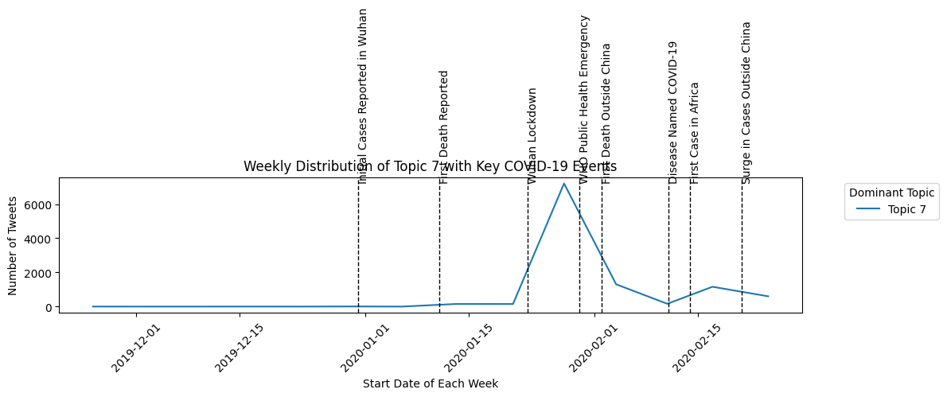A graph with a line and text

  Description automatically generated with medium confidenceA graph with a line

  Description automatically generated
* **Detailed Insight**: The most prevalent topics include public health measures and outbreak updates. The prominence of certain topics aligns with key pandemic events, suggesting a direct correlation between real-world developments and public discourse on Twitter.

**Slide 11: Insight 3 - Public Engagement and Sentiment**

* **Visualization**: 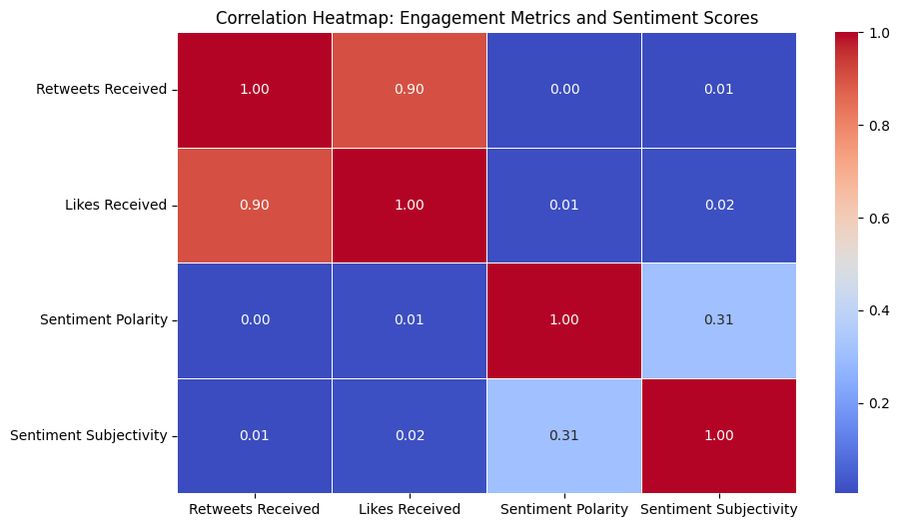.
* **Detailed Insight**: Tweets with extreme sentiments (highly positive or negative) tend to garner more engagement (likes and retweets). This trend indicates that more emotionally charged tweets capture public attention and interaction more effectively.

**Slide 12: Insight 4 - Variability in Subjectivity**

* **Visualization**:

* **Detailed Insight**: Fluctuations in subjectivity suggest a shift between factual reporting and opinionated content. Periods of high subjectivity often coincide with heightened public emotions or reactions to major events in the pandemic timeline.

**Slide 13: Concluding Thoughts**

* **Content**: We synthesized sentiment and topic trends to understand public reactions during the pandemic. These insights are crucial for tailoring public health messages and policies to address public sentiment effectively.

**Slide 14: Q&A Session**

* **Content**: Invite the audience for questions and further discussion on the analysis and its implications.

**Slide 15: Acknowledgments**

* **Content**: Extend thanks to collaborators, data providers, and support teams for their contributions to the project.